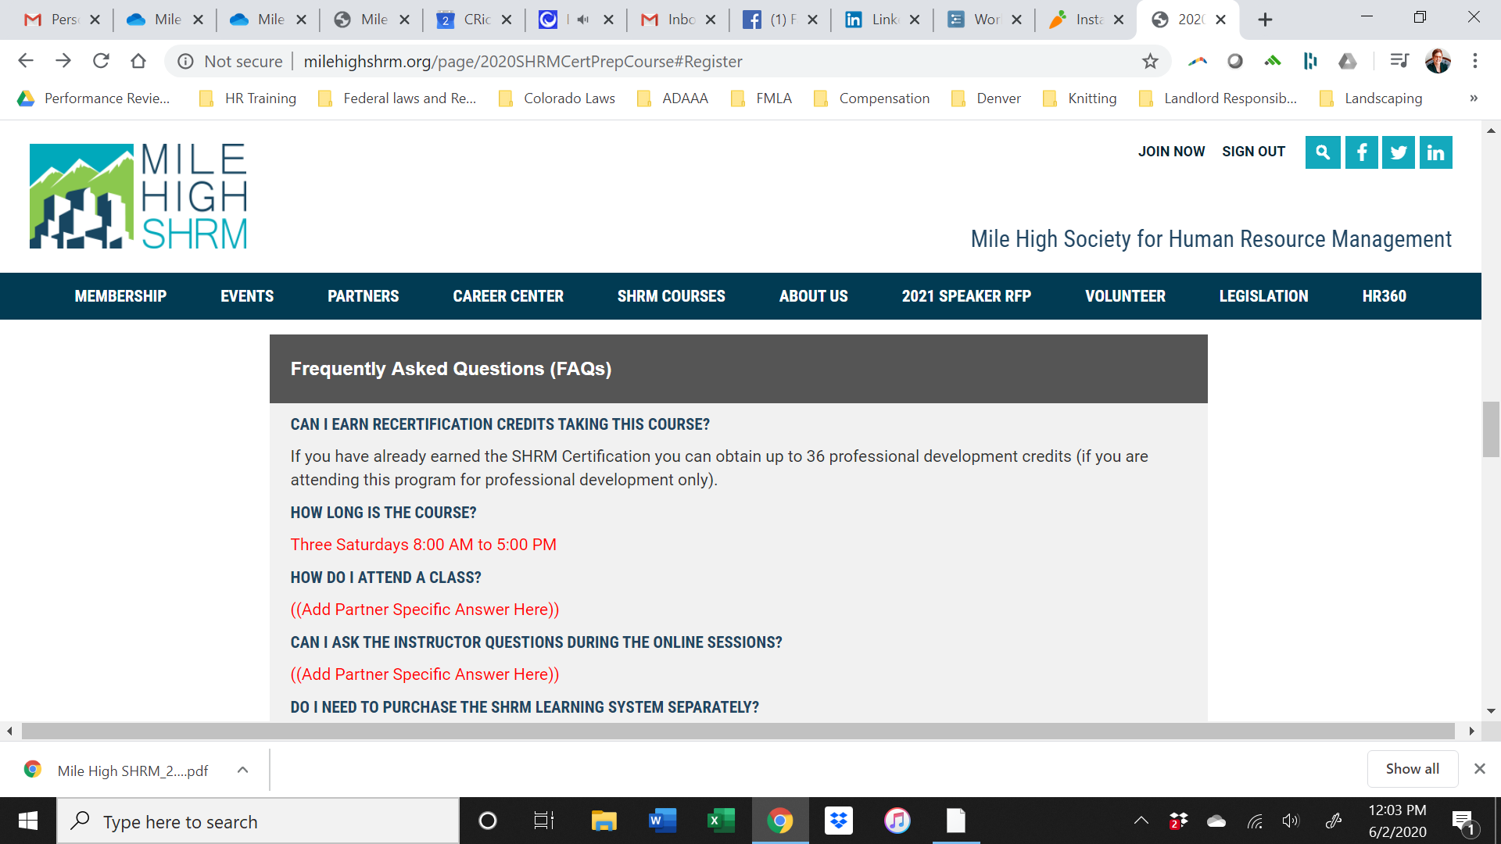

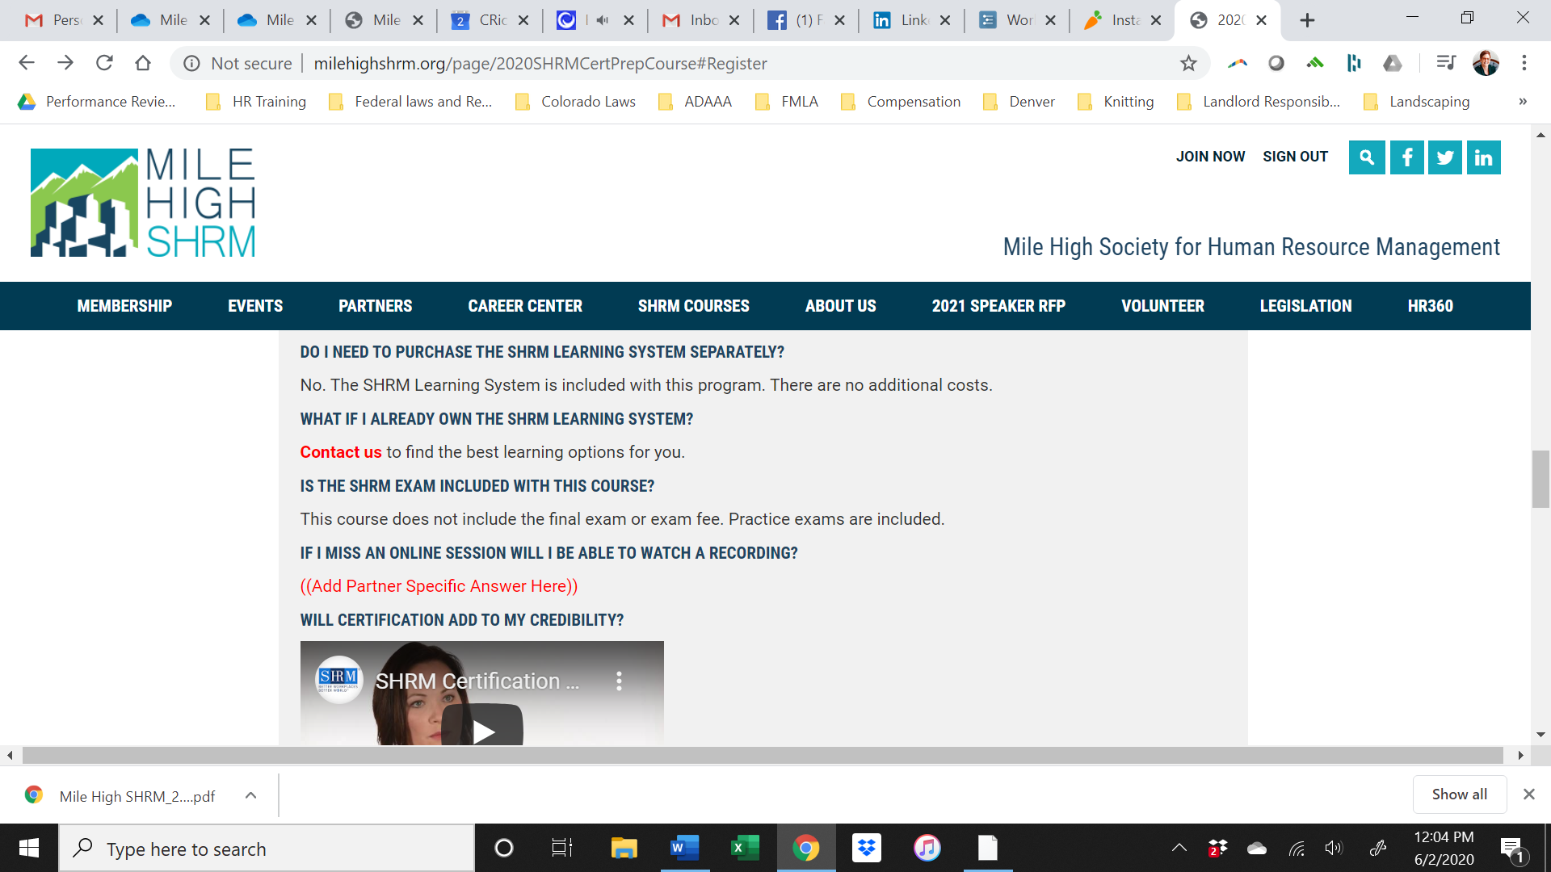

**We need to change all the red to black and the questions we need to answer are below. In Blue is the answer.**

*How do I attend?*

This is an instructor led class on site at Arrow Electronics.

*Can I ask questions….*

* Please delete this

*If I miss….*

* Please delete this

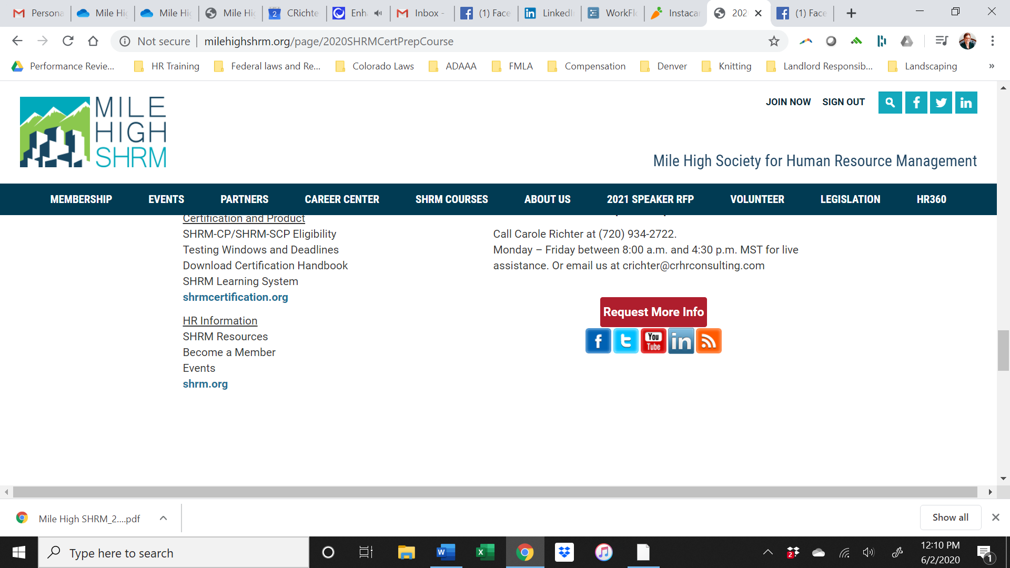

The Request More Info link doesn’t work please link to <https://www.milehighshrm.org/events/EventDetails.aspx?id=1354309&group=>

A new Template available but formatted in WordPress if we need it.